Software Requirements Specification
for
Employee Data Storing System Using Blockchain
Version 1.2 approved
Prepared by Devansh Anhal and Harsha Deuri
NIIT University
5/09/2018
Table of Contents
Table of Contents 1
Revision History 1
1. Introduction 2
1.1 Purpose 2
1.2 Document Conventions 2
1.3 Intended Audience and Reading Suggestions 2
1.4 Product Scope 2
1.5 References 2
2. Overall Description 2
2.1 Product Perspective 2
2.2 Product Functions 3
2.3 User Classes and Characteristics 3
2.4 Operating Environment 3
2.5 Design and Implementation Constraints 3
2.6 User Documentation 4
2.7 Assumptions and Dependencies 4
3. External Interface Requirements 4
3.1 User Interfaces 4
3.2 Hardware Interfaces 4
3.3 Software Interfaces 4
3.4 Communications Interfaces 4
4. System Features 5
4.1 System Feature 1 6
4.2 System Feature 2 7
4.3 System Feature 3 8
4.4 System Feature 4 9
4.5 System Feature 5 10
4.6 System Feature 6 11
4.7 System Feature 7 11
5. Other Nonfunctional Requirements 11
5.1 Performance Requirements 11
5.2 Safety Requirements 11
5.3 Security Requirements 11
5.4 Software Quality Attributes 12
5.5 Business Rules 12
Appendix A: To Be Determined List 12

Revision History
Name | Date | Reason For Changes | Version
Harsha Deuri | 05/09/18 | Initial SRS Draft | 1.0
Devansh Anhal | 18/09/18 | Precision of Requirements | 1.1
Devansh Anhal | 20/09/18 | System Features Updated | 1.1.1
Harsha Deuri | 21/09/18 | Use Case Diagram Added | 1.2

Introduction

Purpose
The product “Secure data storage system using Block chain” is to provide a secure platform for the companies to store sensitive employee data in a public platform. The main purpose of this product will be to restrict any kind of meddling in data,any malpractices done with the data by providing transparency with the help of decentralized application made using blockchain technology.

Document Conventions
Priorities are in the order- 1 highest, 2 second highest and so on.
Also, FR stands for Functional Requirement used under System features.

Intended Audience and Reading Suggestions
This document is intended for the design team, the developing team, the testers, the documentation writers and anyone else who wish to see an outline of the product. The SRS contains specifications of our product and also some of the basic requirements we aim to fulfill.
The reader can study the document sequentially or can choose subsections and continue thereon.

Product Scope
The product will provide the customer a platform to insert data. The data inserted will be stored in blocks and each block will be given a cryptographic hash of the previous block and a timestamp. This will create the block chain affect which will ensure the security. If anyone changes any data in the middle of the pile of blocks, will disrupt the chain and hence the change will be reflected to the public.

References
- IEEE SRS template
- UML Use Case Diagrams

Overall Description

Product Perspective
The product is a standalone product aimed to provide organizations with a transparent data storage platform. Security breaches in databases in organizations is common. Though these meddling may be trivial, it still creates disturbances in the companies’ operations, hence in order to curb these, the idea behind the product evolved.

Product Functions
The major functions the user will be able to perform are:
- login
- input data
- view data
- submit data
- update profile
- calculate bonuses
The product will provide the following functions:
- distributed ledger (peer to peer network)
- creation of block chains
- display of message if data changed.

User Classes and Characteristics
The user classes in the product are anticipated to be:

User Classes | Characteristics
Block | Will create a new block to store the data.
User | The user account will be created. User can update information and log in to their accounts.
Insert_data | Will insert data into the block. Once data is entered it may not be changed
Display | Used to display data from the block. Data can be viewed as monthly, daily or all.
Data_changed | If data is changed, all the users will be notified.

Operating Environment
The product is suggested to run in the following environment
- Linux: 64-bit, supports Ubuntu 12.04
- Windows: 64-bit, supports Windows 7, 8, 10
- 2 GB of RAM
- 1 GB of disk space

Design and Implementation Constraints
The product will require additional plugins to run, without which it cannot be implemented.
The user may not make any changes to the data once it’s been flashed to the chain, even if the data entered was a genuine mistake. However, this is an important constraint that will make the system secure even if it limits certain flexibilities.

User Documentation
Proper documentation and a user guide will be provided (may be video support) or in textual manner. This will be provided in the Help section of the application’s GUI.

Assumptions and Dependencies
The product will be built using Python as its base. The back –end work and the blockchain code will be written in Python. Will be using Django or the Flask framework for the support. The GUI will be represented in the form of a web Application, and its frontend will be developed using the same.

External Interface Requirements

User Interfaces
The user interface is set to be simple and very user friendly.
It will have a home page wherein; the user can login or register themselves. Then they will be directed to a page with a tabular screen space where they can start entering their data. Once they are confirmed with the data, they can submit it. The interface is also set to have date, time and some other basic information’s displaying on every screen. There will also be an option to view the details.

Hardware Interfaces
Although, currently there are no such hardware interfaces required by the product, in the future we intend to develop it further, and allow the customer to connect it to RFID system or a biometric system if required.

Software Interfaces
The blockchain itself acts as a database A Blockchain is a continuously growing list of records, called blocks, which are linked and secured using cryptography. Each block typically contains a cryptographic hash pointer as a link to a previous block, a timestamp and transaction data.

Communications Interfaces
NONE.

System Features
S.No. | Requirement | Description | Priority
1 | Create Account | The Employee will be registered in the app, by providing an offer letter to confirm if he/she belongs to the company or not. | 1
2. | Login | The employee will be logged in with a unique key. | 2
3. | Insert data | All the data about the employee will be fed in his block. | 3
4. | Display Data | Allows the employee to view data in any one of the three options (current data, monthly data, all data) | 5
5. | Display My profile | User can view his profile Also allows user to make minor update to his profile (this update includes trivial data e.g. Address , DOB ,date of joining etc. ) | 6
6 | Bonus | Employee will be given bonus on the bases of company’s policies (how much attendance and tasks he /she has done. | 7
7 | Notify me if change is made | There will be a block which includes crucial data (e.g. employee’s attendance, no. of leaves. No. of tasks completed by the Employee. Etc.) | 4

Create Account
4.1.1 Description and Priority
The user has to register to the system, and provide a number of information like Name, Phone no, Employee id, Email ID and set a password.
Priority: 1
4.1.2 Stimulus/Response Sequences
Stimulus: User requests to create Account by clicking on the Sign Up button
Response: System directs user to the Registration page.
4.1.3 Functional Requirements
FR-1: Sign Up: Allows user to create their account.
FR-2: Create Account: Submits user information to system and creates the user’s account.

Use Case Diagram

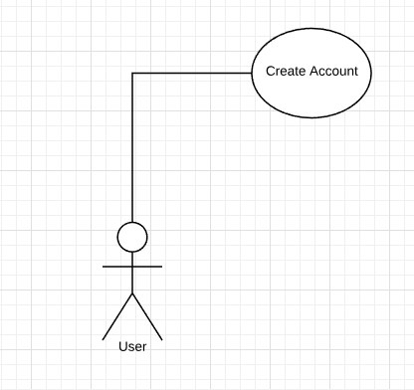

Login
4.2.1 Description and Priority
The user has to login to the system, using their employee id and password.
Priority: 2
4.2.2 Stimulus/Response Sequences
Stimulus: User requests to Login to system by clicking Login Button.
Response: System directs user to Login Page
4.2.3 Functional Requirements
FR-1: Login: Allows user to Login to System.

Use Case Diagram

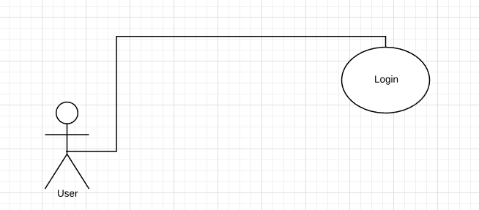

4.3 Insert Data
4.3.1 Description and Priority
The user can insert their details in tabular form (or any other form which will be specified beforehand). The user can perform this function only after logging in to the system.
Priority: 3
4.3.2 Stimulus/Response Sequences
Stimulus: User requests to insert data by clicking the Add My Data Button.
Response: System directs user to the Add data page to insert the data.
4.3.3 Functional Requirements
FR-1: Add My Data: Allows user to insert their data.
FR-2: Submit Data: Allows user to submit their data in to the system by creating a “block”.

Use Case Diagram
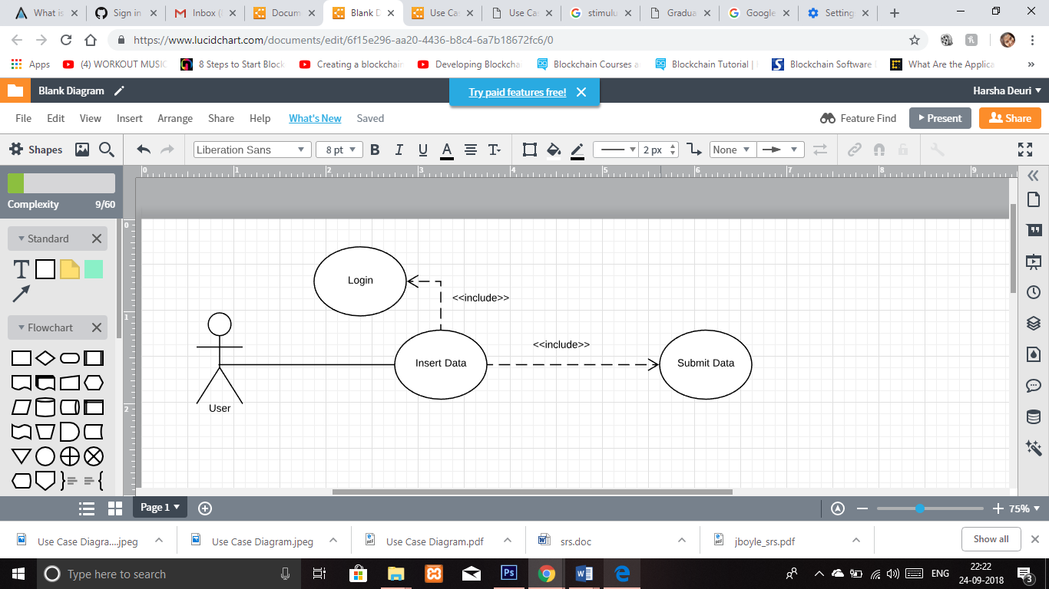

4.4Display Data
4.4.1 Description and Priority
Allows user to view the data: -
  - Current data entered into the system.
  - Data entered over a Month
  - The entire block with everyone’s data
Priority: 5
4.4.2 Stimulus/Response Sequences
Stimulus: User requests the system to display the data
Response: System directs user to a page where he can view his data
4.4.3 Functional Requirements
FR-1: s Allows user to view the data they just entered.
FR-2: View my Stack: Allows user to view their data over the entire month.
FR-3: View the Chain: Allows user to view everyone’s data.

Use Case Diagram
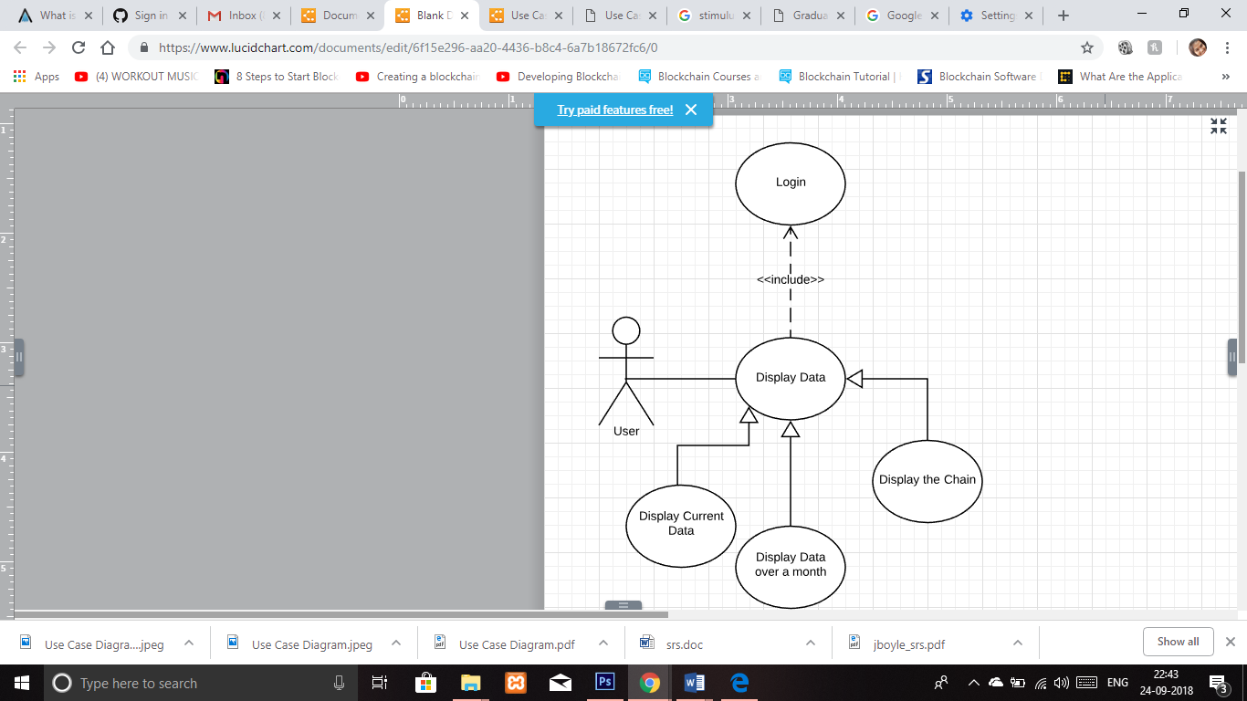

4.5 Display My Profile
4.5.1 Description and Priority
Allows user to display their profile.
Priority: 6
4.5.2 Stimulus/Response Sequences
Stimulus: User requests to view their profile.
Response: System directs the user to a page where he can view his profile.
4.5.3 Functional Requirements
FR-1: My Profile: Allows user to view their profile.
FR-2: Update Profile: User can also choose to update their profile.
FR-3: Save Changes: Allows user to save the changes made to his profile.

Use Case Diagram

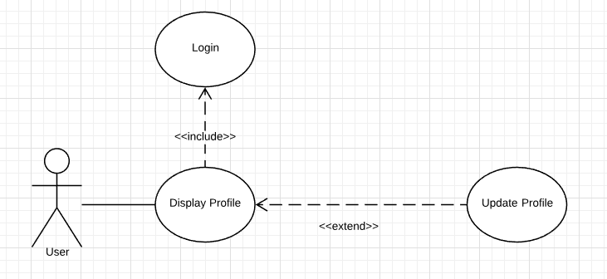

Bonus
4.6.1 Description and Priority
The employee receives bonus on the basis of their attendance. Calculation is done internally and employee can view their bonus at the end of the month, if any.
Priority: 7
4.6.2 Stimulus/Response Sequences
Stimulus: User requests to view his bonus.
Response: System directs the user to a page where he can view his bonus

4.6.3 Functional Requirements
FR-1: Calculate Bonus: System calculates user’s bonus based upon his attendance.
FR-2: View Bonus: Allows user to view his bonus over a month.
FR-3: Nothing to display: Incase user views bonus before end of the month, or if he doesn’t receive any bonus a message will be displayed stating ‘Nothing to Display”.

Use Case Diagram

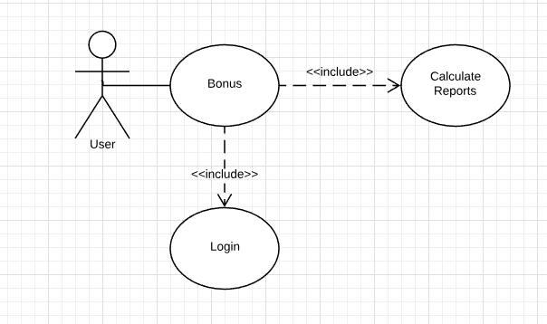

Notify me if change is made
4.7.1 Description and Priority
The user will receive a message in case any kind of meddling is done on the data.
Priority: 4
4.7.2 Stimulus/Response Sequences
Stimulus: Any User meddles with a block.
Response: System sends a message to all the users stating that “A change has been made’.

4.7.3 Functional Requirements
FR-1: Notify bell: User will receive a notification if data is changed.

Use Case Diagram
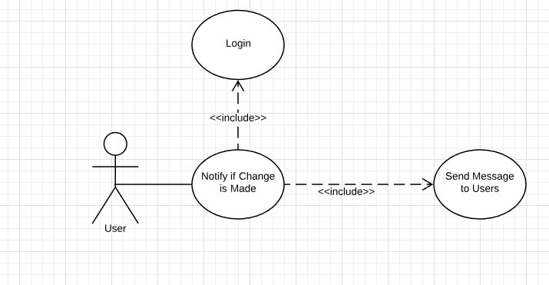

Other Nonfunctional Requirements

Performance Requirements
The system should be up 99% of the time.

Safety Requirements
In case an entire chain is deleted, data will be lost, so user must refrain from doing it unless absolutely necessary. The user must take care to submit the data, and wait for their “block” to be created, otherwise data will be lost.

Security Requirements
Only an authorized user can enter the system, and update their information. No third party or unauthorized (unregistered user) can access the website. There will be no guest login option to ensure this. However once data has been entered into the system, not even an authorized user can alter it, as this is our main security policy

Software Quality Attributes
The most important thing our blockchain app will serve is “proof of publication”. That means that you can create a proof that a certain information existed at a certain point in time, which is totally important in today’s scenario.

Business Rules
The only function the employer will do is feeding the data, via RFID or manual bases. Rest all depends upon our application. There will be no 3rd party involvement.

Appendix A: To Be Determined List
Our project can be further automated by simply connecting our app to an external RFID reader (or any other biometric device) which will remove many manual work like logging into his profile etc.

